# File permissions in Linux

## Project description

In this project, you will examine and modify file system permissions using Linux commands to ensure appropriate authorization for users on a research team. This involves checking existing permissions, determining correct access levels, and updating permissions as necessary.

## Check file and directory details



## Describe the permissions string

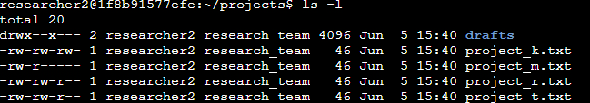

## Change file permissions

Commands used:

**Ls -l** (to view file details)

**Chmod** (to change permissions)

**Chmod o-w project_k.txt** (to change permissions for project_k.txt file where we are removing write permissions for others following the company policy .)

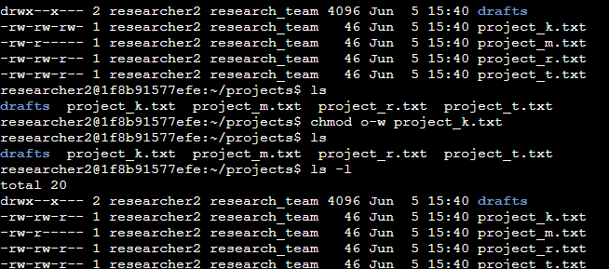

## Change file permissions on a hidden file

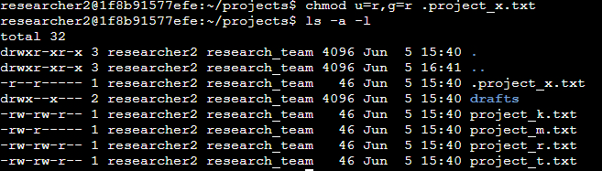

Commands used:

**chmod u=r,g=r .project_x.txt** (to change permissions for the hidden file .project_x.txt to only read for all users and groups)

## Change directory permissions

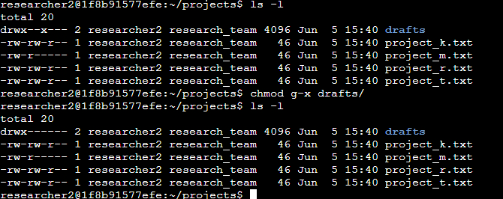

Commands used:

**chmod g-x drafts/ (to change permissions and remove executable permissions for group)**

## Summary

In this project, you will ensure proper authorization for users on a research team by examining and modifying file system permissions using Linux commands. You will:

1. Identify the File or Directory: Determine the path to be checked (e.g., `/research_data/project1`).

2. Check Current Permissions: Use the `ls -l` command to review existing permissions.

3. Set Appropriate Permissions: Use `chmod`, `chown`, and `chgrp` commands to update permissions and ownership as needed.

4. Verify Changes: Recheck the permissions to confirm they are correctly applied.